CSCI3420 Computer System Architectures
Project Phase 1
Deadline: 23:59 20th Feb, 2012

Introduction
In order to have a more in depth understanding of CPU architecture, you have to write assembly programs, a single-cycle simulator and a multi-cycle pipelined simulator of a simplified CPU. The project is divided into 3 related phases. In the phase 1, you have to write two assembly programs to gain more understanding of assembly programming.

Assembly Programs
- The objective is to help you to understand assembly language. You are required to write two small assembly programs according to the mod (last two digits of your student ID, 48) & the following hash table.

For example, if you student ID is 1155000549. Mod (49, 48) = 1. From the table you need to write programs for problems 1 and 7.

Mod 48 | Problems | Mod 48 | Problems | Mod 48 | Problems | Mod 48 | Problems
0 | 1, 3 | 12 | 1, 4 | 24 | 1, 5 | 36 | 1,6
1 | 1, 7 | 13 | 1, 8 | 25 | 2, 3 | 37 | 2, 4
2 | 2, 5 | 14 | 2, 6 | 26 | 2, 7 | 38 | 2, 8
3 | 3, 1 | 15 | 3, 2 | 27 | 3, 5 | 39 | 3, 6
4 | 3, 7 | 16 | 3, 8 | 28 | 4, 1 | 40 | 4, 2
5 | 4, 5 | 17 | 4, 6 | 29 | 4, 7 | 41 | 4, 8
6 | 5, 1 | 18 | 5, 2 | 30 | 5, 3 | 42 | 5, 4
7 | 5, 7 | 19 | 5, 8 | 31 | 6, 1 | 43 | 6, 2
8 | 6, 3 | 20 | 6, 4 | 32 | 6, 7 | 44 | 6, 8
9 | 7, 1 | 21 | 7, 2 | 33 | 7, 3 | 45 | 7, 4
10 | 7, 5 | 22 | 7, 6 | 34 | 8, 1 | 46 | 8, 2
11 | 8, 3 | 23 | 8, 4 | 35 | 8, 5 | 47 | 8, 6
Problem set hash table

- We will use QtSpim as the MIPS simulator for testing. You can use any instruction covered by QtSpim. All instructions mentioned in lectures and tutorials are covered in the QtSpim.

- You are given an assembly program for each problem. You need to complete the core part of the assembly program to perform the desired task. The code segment we provided will set the initial values to registers and memory and also print the answer after your code segment.

- Before entering your program segment, you can assume the registers and memory contains the initial values defined by the question.

- The console window of QtSpim will print the final values of the register and memory. You should check the output to make sure your program is correct.

Problem1: Sort the numbers in ascending order

In this program, one integer n ≥ 2 is given in $s1 and one address addr is given in $s2 before your programs starts. n is the amount of numbers and addr is the memory address that store the address of the first number. Size of each number is ONE WORD. When your program reaches the end, the numbers in the memory should be sorted in ASCENDING order. Smaller address contains smaller numbers.
Example:
n = 10, addr = 0x0000

Before program starts  $s1 = 0x000a and $s2 = 0x0000 | After program ends  $s1 = 0x000a and $s2 = 0x0000
  Memory Address | Content
  0x0000 | 0x12 (18)
  0x0004 | 0x03 (3)
  0x0008 | 0xb (11)
  0x000c | 0x7 (7)
  0x0010 | 0xd (13)
  0x0014 | 0x5 (5)
  0x0018 | 0x9 (9)
  0x001c | 0xf (15)
  0x0020 | 0x1 (1)
  0x0024 | 0x10 (16)
  Memory Address | Content
  0x0000 | 0x1 (1)
  0x0004 | 0x3 (3)
  0x0008 | 0x5 (5)
  0x000c | 0x7 (7)
  0x0010 | 0x9 (9)
  0x0014 | 0xb (11)
  0x0018 | 0xd (13)
  0x001c | 0xf (15)
  0x0020 | 0x10 (16)
  0x0024 | 0x12 (18)

Problem2: Find the medium

In this program, one integer n ≥ 2 is given in $s1 and one address addr is given in $s2 before your programs starts. n is the amount of numbers and addr is the memory address that store the address of the first number. Size of each number is ONE WORD. When your program reaches the end, the medium should be found and store in the registers. If the amount of numbers is odd, $s1 should store the medium of the number in the array. If the amount of numbers is even, $s1 and $s2 should store the mediums respectively, where $s1 < $s2.
Example:
n = 10, addr = 0x0000

Before program starts  $s1 = 0x000a and $s2 = 0x0000 | After program ends  $s1 = 0x0009 and $s2 = 0x000b
  Memory Address | Content
  0x0000 | 0x12 (18)
  0x0004 | 0x03 (3)
  0x0008 | 0xb (11)
  0x000c | 0x7 (7)
  0x0010 | 0xd (13)
  0x0014 | 0x5 (5)
  0x0018 | 0x9 (9)
  0x001c | 0xf (15)
  0x0020 | 0x1 (1)
  0x0024 | 0x10 (16)

Problem3: Count the numbers that are even

In this program, address addr is stored in $s1 before your programs starts. An array of integers is stored in the memory and addr is the memory address of the first number. Size of each integer is ONE WORD. The last element of the array is always ZERO and all other numbers are non-zero. When your program reaches the end, $s1 should store one value, which is the number of EVEN numbers in the array.

Example: addr = 0x0000

Before program starts  $s1 = 0x0000 | After program ends  $s1 = 0x0003
  Memory Address | Content
  0x0000 | 0x2 (2)
  0x0004 | 0x1 (1)
  0x0008 | 0xf (15)
  0x000c | 0x8 (8)
  0x0010 | 0x0 (0)
  0x0014 | Don’t Care
  Memory Address | Content
  0x0000 | 0x2 (even)
  0x0004 | 0x1 (odd)
  0x0008 | 0xf (odd)
  0x000c | 0x8 (even)
  0x0010 | 0x0 (even)
  0x0014 | Don’t Care

Problem4: Sum the first n Fibonacci number

In this program, one positive integer n is stored in $s1 before your programs starts. When your program reaches the end, $s1 should store one value, which is the sum of the first n Fibonacci number.

Example: n = 5, sum of first five Fibonacci number = 0 + 1 + 1 + 2 + 3 = 7

Before program starts  $s1 = 0x0005 | After program ends  $s1 = 0x0007

Problem5: Sum all the digits of the number until a single digit is obtained

In this program, one positive binary integer x is given in $s1 before your program starts. Your program should SUM all the digits of x in DECIMAL representation repeatedly until a single digit is obtained. When your program reaches the end, $s1 should contain the digit sum (in binary).

Example: If x = 0x00000100, (= 256 in decimal), digit sum = 2 + 5 + 6 = 13 → 1 + 3 = 4 in decimal, (0x4)

Before program starts  $s1 = 0x100 (256) | After program ends  $s1 = 0x4 (4)

Problem6: Find Greatest Common Factor and Least Common Multiple

In this program, two positive binary integer x and y is given in $s1 and $s2 before your program starts. Your program should find the greatest common factor and least common multiple of x and y. When your program reaches the end, $s1 should contain the greatest common factor and $s2 should store the least common multiple.

Example: If x = 0x00000100, (= 256 in decimal) and y = 16, greatest common factors = 16 and least common multiple = 256

Before program starts  $s1 = 0x100 (256) and $s2 = 0x10 (16) | After program ends  $s1 = 0x10 (16) and $s2 = 0x100 (256)

Problem7: Determine Pythagorean triple
In this program, three positive integers a, b and c are given in $s1, $s2 and $s3. This triple, a, b and c are in random order. When your program reaches the end, $s1 should be 1 if (a, b, c) is a Pythagorean triple, 0 otherwise. A Pythagorean triple consists of three positive integers, the square of the biggest number = sum of the square of the two smaller numbers.

Example:
If a = 3, b = 5 and c = 4, (3, 4, 5) is a Pythagorean triple.

Before program starts  $s1 = 0x3  $s2 = 0x5  $s3 = 0x4 | After program ends  $s1 = 0x1  $s2 = 0x5  $s3 = 0x4

When a = 10, b = 4 and c = 3

Before program starts  $s1 = 0xA  $s2 = 0x4  $s3 = 0x3 | After program ends  $s1 = 0x0  $s2 = 0x4  $s3 = 0x3

Problem8: Determine prime number

In this program, one positive integer x ≥ 2 is given in $s1 before your program starts, when your program reaches the end, $s1 should be 1 if x is prime number, 0 otherwise.

Example:
x = 7, which is a prime number

Before program starts  $s1 = 0x7 | After program ends  $s1 = 0x1

x = 8, which is not a prime number

Before program starts  $s1 = 0x8 | After program ends  $s1 = 0x0

Assessment of Correctness
We will use the simulator to assess the correctness of your assembly program. The simulator we will use to test your program segment is QtSpim. The version is 9.1.7. The testing environment is Windows. Set the simulator as Simple Machine, which accepts pseudo instructions.

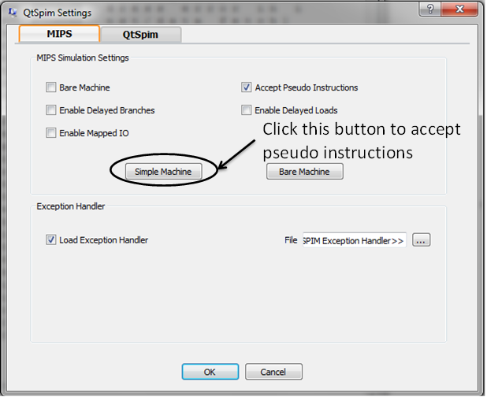
Webpage: http://spimsimulator.sourceforge.net/
Download link: http://sourceforge.net/projects/spimsimulator/files/

The program segment we provided will print the answer stored in the register or the memory in the console. We will check whether your program can print the correct answer.

Sample output for Problem 1:
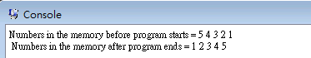

Marking Scheme

You need to submit TWO assembly programs according to the hash index. Each assembly program contributes 50% to the project phase 1.

Submission Guidelines

- Name the assembly programs as “Problem” + X + “.asm” and “Problem” + Y + “.asm” where X & Y are the problem numbers.

For example, if you student ID is 1155000599. Mod (99, 48) = 3. From the table you need to write programs for problems 1 and 3. Your file should be labeled as “Problem1.asm” and “Problem3.asm”

- Zip the assembly programs as sid.zip where sid = your student ID

- You MUST submit the ZIP file to the submission system on our course homepage (within CUHK network), otherwise, we will NOT mark your assignment.

- Late submission will NOT be entertained according to our submission system settings.

- You can submit your project to our submission system infinite times, and only the most updated files will be marked.

- Plagiarism will be seriously punished. We may randomly interview some students to check if they have done the problems themselves.

Assembler Syntax

Some basic assembler syntax is:

- Comments begin with a sharp (#) and effective till the end of line.
- Identifiers (for labels) consist of alphanumeric characters, underscore (_), dots (.), but do NOT start with numbers.
- The identifiers are case-sensitive.
- Instruction opcodes are reserved words that cannot be used as identifiers.
- Labels consist of an identifier, followed by a colon (:), and are declared at the beginning of a line.
- Numbers are base 10 by default.

Registers Name
Here are the registers conventions in QtSpim.

Register name | Number | Usage
$zero | 0 | constant 0
$at | 1 | reserved for assembler
$v0 | 2 | expression evaluation and results of a function
$v1 | 3 | expression evaluation and results of a function
$a0 | 4 | argument 1
$a1 | 5 | argument 2
$a2 | 6 | argument 3
$a3 | 7 | argument 4
$t0 | 8 | temporary (not preserved across call)
$t1 | 9 | temporary (not preserved across call)
$t2 | 10 | temporary (not preserved across call)
$t3 | 11 | temporary (not preserved across call)
$t4 | 12 | temporary (not preserved across call)
$t5 | 13 | temporary (not preserved across call)
$t6 | 14 | temporary (not preserved across call)
$t7 | 15 | temporary (not preserved across call)
$s0 | 16 | saved temporary (preserved across call)
$s1 | 17 | saved temporary (preserved across call)
$s2 | 18 | saved temporary (preserved across call)
$s3 | 19 | saved temporary (preserved across call)
$s4 | 20 | saved temporary (preserved across call)
$s5 | 21 | saved temporary (preserved across call)
$s6 | 22 | saved temporary (preserved across call)
$s7 | 23 | saved temporary (preserved across call)
$t8 | 24 | temporary (not preserved across call)
$t9 | 25 | temporary (not preserved across call)
$k0 | 26 | reserved for OS kernel
$k1 | 27 | reserved for OS kernel
$gp | 28 | pointer to global area
$sp | 29 | stack pointer
$fp | 30 | frame pointer
$ra | 31 | return address (used by function call)

How to use QtSpim

QtSpim User Interface:
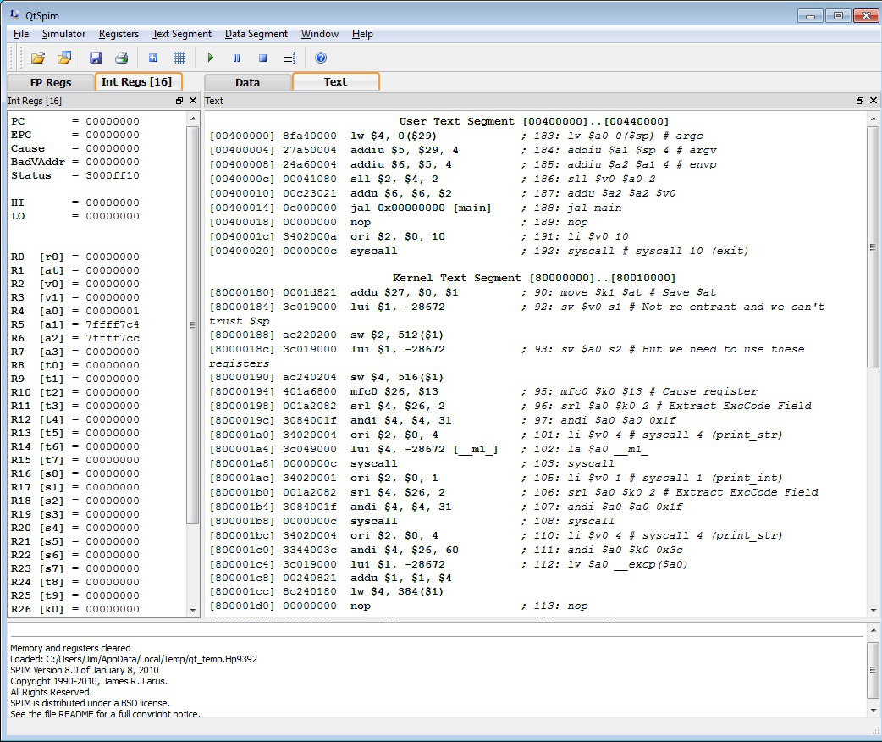
The left panel shows register content.
The right panel shows data segment and text segment content.

How to run your program:

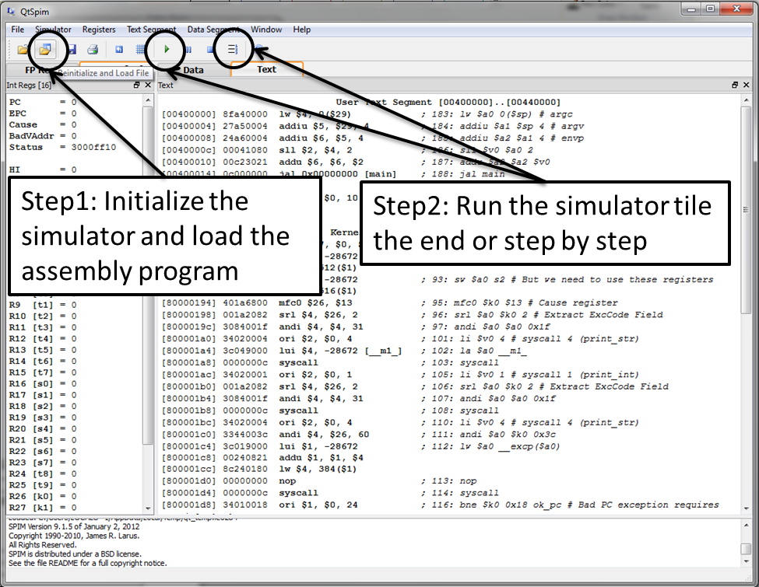

Show the console:
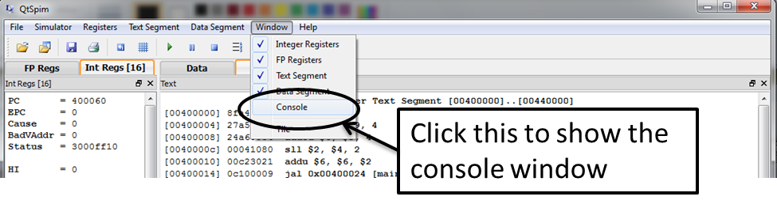

------------ End of this Document ----------

